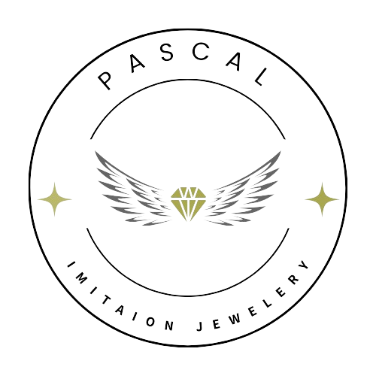

***PASCAL IMITAION JEWELRY***

|  |  |  |
| --- | --- | --- |
| **Supervisor.** | Miss Yumna Khalid | |
| **Batch.** | 2505B1 | |
| **Group.** | Team (B) | |
| **Serial No.** | **Enrollment Number.** | **Student name.** |
|  | Student1655435 | Hasan Khan |
|  | Student1652968 | Awun-Ur-Rehman |
|  | Student1653170 | Hammad Qureshi |
|  | Student1648586 | Zeerak Baqer |
|  | Student1648587 | Ali Mehdi |

***ACKNOWLEDGEMENT***

We would like to express our heartfelt gratitude to everyone who contributed to the creation and launch of **Pascal Imitation Jewelry**.

First and foremost, we thank our **customers and supporters**, whose encouragement and trust in our products have inspired us to bring this brand to life. Your appreciation for art, elegance, and craftsmanship fuels our passion every single day.

A special thanks goes to our **design and development team**, whose creativity and attention to detail have helped shape the unique aesthetic of Pascal Imitation Jewelry. Your dedication to quality and innovation ensures that each piece reflects both beauty and individuality.

We also extend our sincere appreciation to our **web development and marketing partners** for helping us build a platform that is not only visually captivating but also user-friendly. Your expertise made it possible for us to reach a wider audience and connect meaningfully with our customers.

To our **suppliers and artisans**, thank you for your collaboration and commitment to excellence. Your craftsmanship is the backbone of our brand and the key to delivering premium imitation jewelry to our clientele.

Lastly, we thank our **families and friends** for their unwavering support and patience throughout this journey. Your belief in our vision made all the difference.

With deepest appreciation,  
**The Pascal Imitation Jewelry Team**

***SYNOPSIS***

**Project Name**: Pascal Imitation Jewelry Website  
**Industry**: Fashion  
**Website**: www.PIJ.com  
**Date**: 23 Sep 2025

**Overview**:  
Pascal Imitation Jewelry is an online platform offering stylish, high-quality imitation jewelry at affordable prices. The website showcases a curated collection of modern and traditional pieces designed for fashion-conscious individuals.

**Objective**:  
To provide a seamless and elegant shopping experience, promote the Pascal brand online, and make premium-looking jewelry accessible to all.

**Key Features**:

* Responsive and user-friendly design
* Product categories
* Detailed Product Pages
* Customer login form
* Social media integration

**Target Audience**:  
Women aged 18–45, fashion enthusiasts, and budget-conscious shoppers.

**Technology Stack**:  
HTML, CSS, JavaScript, jQuery and Bootstrap.

***PROBLEM DEFINITION***

In today’s fashion landscape, many consumers desire elegant and premium-looking jewelry but are often restricted by high prices, limited local availability, or lack of access to reliable online platforms.

**Pascal Imitation Jewelry** aims to address this gap by providing a dedicated, user-friendly online platform where customers can browse, select, and purchase high-quality imitation jewelry that combines affordability with style.

Currently, many small and mid-range jewelry brands lack a digital presence or provide a poor online shopping experience—leading to lost sales and weak brand visibility. Without a secure, well-designed website, these businesses struggle to reach modern consumers who prefer the convenience of online shopping.

**The problem**:

* Lack of accessible, affordable fashion jewelry platforms online.
* Limited product discovery and poor user experience on existing small brand websites.
* Trust issues in quality and security during online transactions.
* Minimal digital branding for local imitation jewelry businesses.

**Solution Goal**:  
To develop a responsive, aesthetically pleasing, and secure e-commerce website that enables Pascal Imitation Jewelry to showcase its products, connect with its audience, and provide a seamless shopping experience—ultimately enhancing reach, customer satisfaction, and sales.

***SYSTEM REQUIREMENT SPECIFICATION (SRS)***

After discussing the Details about the website, we believe to start creating website as per as customers requirement

The Home Page should be created making use of Sections with a suitable logo, the header section can be added which will display our new collections and offers.

The site must contain the links to navigate through any category for the information.

The site should display a menu which will contain the options for brief introduction about the various products available, location of the shop and any other information if required.

The information should be categorized according to the various crystals like if a User wants to see only “Diamond/Amber/Amethyst etc.” products then he/she can click on a Link/button/menu etc., and can see only that crystal products.

When a user selects any particular crystal, a list of all the products for that crystal will be displayed

***HARDWARE & SOFTWARE REQUIREMENT***

**1. Hardware Requirements**

* **Device**: Smartphone, Tablet, Laptop, or Desktop
* **Processor**: Minimum 1 GHz (dual-core or higher recommended)
* **RAM**: Minimum 2 GB
* **Internet**: Minimum 2 Mbps connection
* **Browser**: Latest version of Chrome, Firefox, Safari, or Edge

**2. Software Requirements**

**Frontend Technologies:**

* HTML5, CSS3, JavaScript.
* jQuery, Bootstrap.

**Operating System:**

* Windows
* MacOS

***SCOPE OF THE WORK***

This project involves the planning, execution, and delivery of **Pascal Imitation Jewelry**, including but not limited to:

* **Site assessment and preparation**
* **Procurement of necessary materials and equipment**
* **Testing and commissioning**
* **Final handover and documentation**

The work shall be carried out in accordance with the approved specifications, standards, and timelines agreed upon by both parties. Any work outside this scope will require written approval and may be subject to additional costs and time extensions.

***LOGIN FORM***

***CONTACT FORM***

***FEEBACK + LINK TO CONTACT***

***TEAM & WEB DESC***

***RINGS***

***NECKLACE***

***CUFFLINKS***

***WATCHES***

***BANGLES***

***HIGHLIGHTS OF THE WEBSITE***

***CONTACT***

***FEEDBACK***

***GALLERY***

***ABOUT***

***LOGIN***

***HOME***

***SITEMAP***

***TASK SHEET REVIEW***

|  |  |  |  |  |  |  |
| --- | --- | --- | --- | --- | --- | --- |
| **Project Ref. No.: EP/Advertisement Portal Management System/01** | | **Project Title** | **Dates of Preparation of Activity Plan** | | | |
| No. | **Task** | PASCAL IMITAION JEWELRY | **Actual Start Date** | **Actual Days** | **Team-mate Names** | **Status** |
| **1.** | **Build Home Page** |  |  | **Awun-Ur-Rehman** | **Complete** |
| **2.** | **Build About-us Page** |  |  | **Hasan, Awun** | **Complete** |
| **3.** | **Build Gallery Page** |  |  | **Hasan Khan** | **Complete** |
| **4.** | **Build All Sub Pages** |  |  | **Hasan Khan** |  |
| **5.** | **Build Contact-Us Page** |  |  | **Hasan Khan** | **Complete** |
| **6.** | **Build Feedback Page** |  |  | **Hammad Qureshi** | **Complete** |
| **7.** | **Build Login Page** |  |  | **Awun-Ur-Rehman** | **Complete** |
| **8.** | **Logo, Images, Header & Footer** |  |  | **Hasan, Zeerak, Ali Mehdi** | **Complete** |
| **9.** | **Documentation** |  |  | **Hasan, Awun, Hammad** | **Complete** |